Commerce on Rails™ for newline Creations, LLC

Financial and Cost Benefit Analysis

February 27, 2006

Group Six:
Rachel Messham
Lukasz Karapuda
Dick Granberg
Michael Mayer

Information Technology Masters Capstone
ITEC-6800

Prof. Hughes

Financial Analysis
The Commerce on Rails project will be immediately usable by the client in generating revenue. Implementation of the software has been analyzed over a three-year payback period, starting in the year of implementation (year 0). Market research indicates that there will be an estimated 200,000 potential website development customers over the three years of the payback period. newline Creations has targeted a 5% share (10,000) of this market to be built using the Commerce on Rails software. With the assumption of this market penetration, and the volume distribution assumptions and price points in Table 1 below, the project appears very favorable. The return on investment is 243% over the three years, with positive net revenue in every year of the period. With an initial project cost of $69,300, the project pays for itself during the first year.

Table 1
 | Year 0 | Year 1 | Year 2
Licenses | 2000 | 3000 | 5000
Developed Web Sites | 100 | 200 | 200
Enhancement Cycles | 1 | 2 | 2
Licensed enhancements per cycle | 1000 | 1500 | 2500
Enhanced Web Sites per cycle | 50 | 100 | 100
Unit Licensing Price | $250 | $275 | $300
Unit Enhancement Price | $25 | $27.5 | $30

The costs, revenue, and net returns are shown in Figure 1 below for the years of the analysis period.
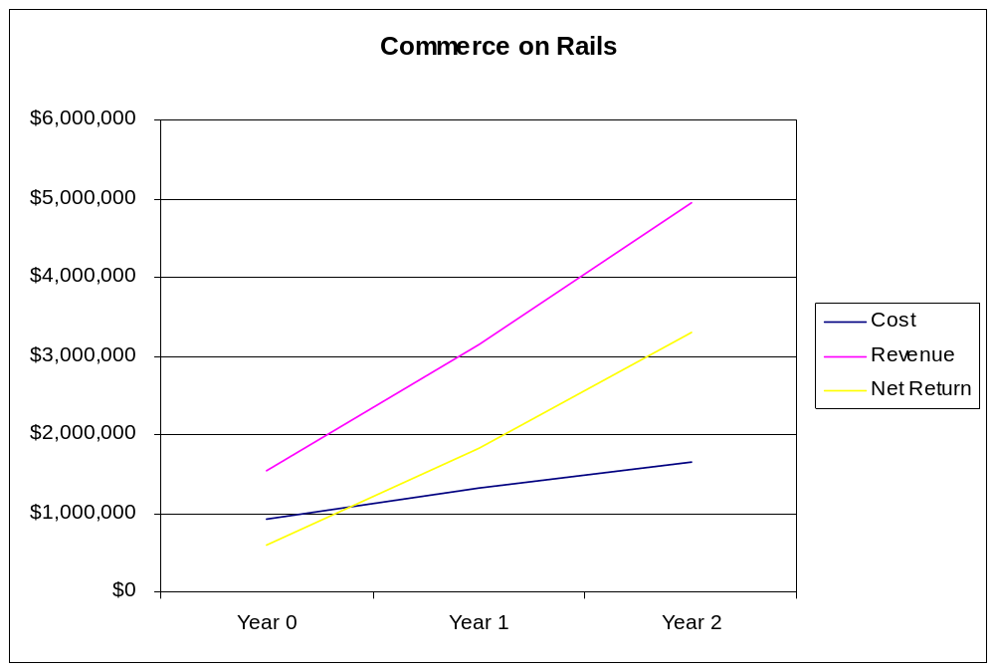
Figure 1

Costs
The costs break out into four areas:
- Project development
- Project implementation
- Ongoing costs (licensing of software and utilization in client work)
- Incremental software enhancements

Cost summaries -
Project Development
 | Year 0 | Year 1 | Year 2 | Total | Present Value
Total Cost | $44,150 | $0 | $0 | $44,150 | $44,150

Project implementation
 | Year 0 | Year 1 | Year 2 | Total | Present Value
Total Cost | $25,150 | $0 | $0 | $25,150 | $25,150

Ongoing costs (licensing of software and utilization in client work)
 | Year 0 | Year 1 | Year 2 | Total | Present Value
Total Cost | $808,880 | $1,206,005 | $1,495,255 | $3,510,140 | $3,242,001

Incremental software enhancements
 | Year 0 | Year 1 | Year 2 | Total | Present Value
Total Cost | $51,125 | $121,500 | $160,000 | $332,625 | $304,427

The cost during each year is a combination of fixed costs for licensing activities and for software utilization activities, and a marginal cost far each unit licensed or used in website development.

Revenues

The revenues derive from several areas:
- Licensing of the software to developers
- Utilization of the software in newline work
- Unrelated business stimulated by enhanced reputation or brand

Although the software will enable significant reductions in development time, this cost reduction was assumed to be zero for purposes of this analysis.

Revenue summary:
Software Licensing and Utilization |  |  | Year 0 | Year 1 | Year 2
Licensing |  |  | 950,000.00 | 1,982,500.00 | 3,775,000.00
Utilization |  |  | 530,250.00 | 1,060,500.00 | 1,060,500.00
Collateral Benefits |  |  | 53,025.00 | 106,050.00 | 106,050.00
Total revenue from software licensing and utilization |  |  | 1,533,275.00 | 3,149,050.00 | 4,941,550.00

Return on Investment and Payback

With an assumed discount rate of 7%, the return on investment over the three year period is 243%. As was noted previously, with a project development and implementation cost of $69,300 the project pays for itself in the first year (refer to Figure 1)

Return on Investment:
 | Year 0 | Year 1 | Year 2 | NPV
Cost | $929,305 | $1,327,505 | $1,655,255 | $3,615,728
Revenue | $1,533,275 | $3,149,050 | $4,941,550 | $8,792,454
Net Return | $603,970 | $1,821,545 | $3,286,295

